**ARQUITECTURA WEB**

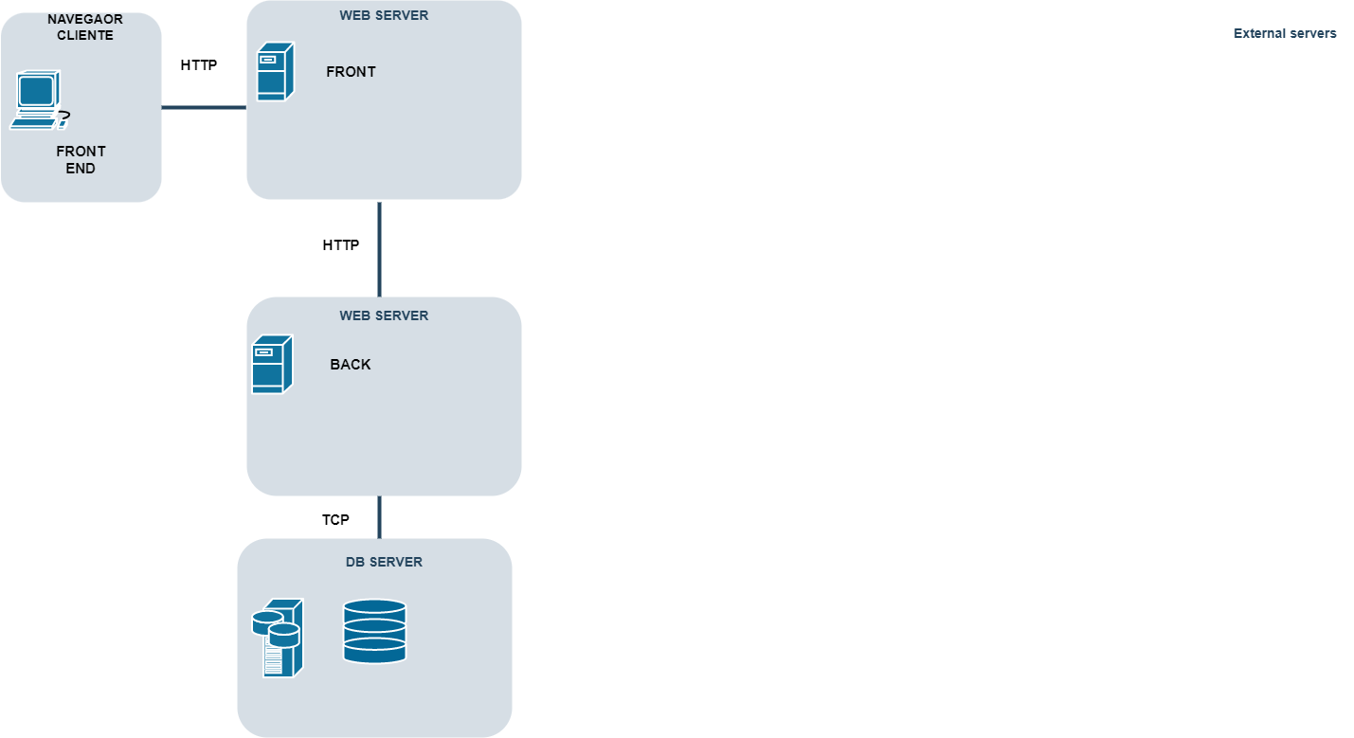

%3CmxGraphModel%3E%3Croot%3E%3CmxCell%20id%3D%220%22%2F%3E%3CmxCell%20id%3D%221%22%20parent%3D%220%22%2F%3E%3CmxCell%20id%3D%222%22%20value%3D%22%26lt%3Bb%26gt%3B%26lt%3Bfont%20style%3D%26quot%3Bfont-size%3A%2015px%3B%26quot%3B%26gt%3BHTTP%26lt%3B%2Ffont%26gt%3B%26lt%3B%2Fb%26gt%3B%22%20style%3D%22text%3Bhtml%3D1%3BstrokeColo%3Dnone%3BfillColor%3Dnone%3Balign%3Dcenter%3BverticalAlign%3Dmiddle%3BwhiteSpace%3Dwrap%3Brounded%3D0%3BfontSize%3D14%3B%22%20vertex%3D%221%22%20parent%3D%221%22%3E%3CmxGeometry%20x%3D%22640%22%20y%3D%22260%22%20width%3D%2260%22%20height%3D%2230%22%20as%3D%22geometry%22%2F%3E%3C%2FmxCell%3E%3C%2Froot%3E%3C%2FmxGraphModel%3E